CONTROLLER PROGRAMMING
01. Timer1 Programming using Interrupt  ( From Lecture):-  void init_port();  void init_timer();  void setup() {  volatile long i;  int j=0;  init_port();  init_timer();  Serial.begin(9600);  while(1)  {  for(i=0; i<500000; i++);  Serial.println(j,DEC);  j++;  }  }  void init_timer(){  volatile char *Timer1_TCCR1A = 0x80; // Timer/Counter 1 Control Register A  volatile char *Timer1_TCCR1B = 0x81; // Timer/Counter 1 Control Register B  volatile short *Timer1_TCNT1 = 0x84; // Timer/Counter 1 Register  volatile short *Timer1_OCR1A = 0x88; // Output Compare Register 1 A  volatile char *Timer1_TIMSK1 = 0x6F; // Timer/Counter 1 Interrupt Mask register  *Timer1_TCCR1A = 0;  //*Timer1_TCCR1B = 0;  *Timer1_TCCR1B = 0x0c; // TCCR1A & TCCR1B are assigned such that the timer 1 acts as CTC mode and clk/256 prescaler mode  *Timer1_TCNT1 = 0; // count 0 to OCR1A value  *Timer1_OCR1A = 60000; // our required value  *Timer1_TIMSK1 = 0x02; // set the interrupt mask register OCIE1A bit  } | void init_port(){  volatile char *portf_dir = (volatile char *) 0x30;  *portf_dir = 0x01;  }  ISR(TIMER1_COMPA_vect){  volatile char *portf_data = (volatile char *) 0x31;  *portf_data ^= 0x01;  }  void loop() {}  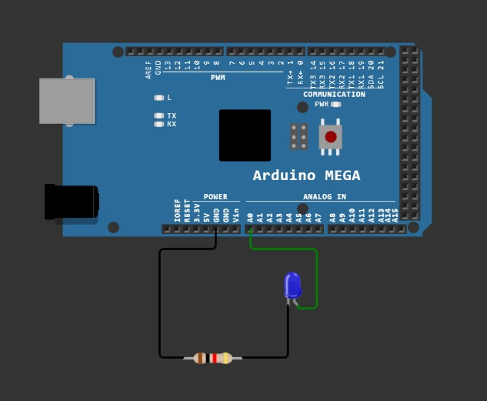
Timer0 & Timer2 (8-bit Timer/Counter) Programming
02. Timer1 & Timer2 Programming using Interrupt ( From Lecture):-  void init_port();  void init_timer1();  void init_timer3();  volatile char *portf_data;  volatile char *portk_data;  void setup() {  volatile long i;  int j=0;  init_port();  init_timer1();  init_timer3();  Serial.begin(9600);  while(1)  {  for(i=0; i<500000; i++);  Serial.println(j,DEC);  j++;  }  }  void init_timer3(){ // By using Normal mode  volatile char *Timer3_TCCR3A = 0x90;  volatile char *Timer3_TCCR3B = 0x91;  volatile short *Timer3_TCNT3 = 0x94;  volatile char *Timer3_TIFR3 = 0x71;  *Timer3_TCCR3A = 0;  *Timer3_TCCR3B = 0x04;  *Timer3_TCNT3 = 0;  *Timer3_TIFR3 = 1;  }  void init_timer1(){ // By using CTC mode  volatile char *Timer1_TCCR1A = 0x80;  volatile char *Timer1_TCCR1B = 0x81;  volatile short *Timer1_TCNT1 = 0x84;  volatile short *Timer1_OCR1A = 0x88;  volatile char *Timer1_TIMSK1 = 0x6F; | *Timer1_TCCR1A = 0;  //*Timer1_TCCR1B = 0;  *Timer1_TCCR1B = 0x0c; // TCCR1A & TCCR1B are assigned such that the timer 1 acts as CTC mode and clk/256 prescaler mode  *Timer1_TCNT1 = 0; // count 0 to OCR1A value  *Timer1_OCR1A = 8000; // our required value  *Timer1_TIMSK1 = 0x02; // set the interrupt mask register OCIE1A bit  }  void init_port(){  volatile char *portf_dir = 0x30, *portk_dir = 0x107;  *portf_dir = 0x01; *portk_dir = 1;  portf_data = 0x31; portk_data = 0x108;  }  ISR(TIMER1_COMPA_vect){  *portf_data ^= 0x01;  }  ISR(TIMER3_OVF_vect){  *portk_data ^= 0x01;  }  void loop() {}  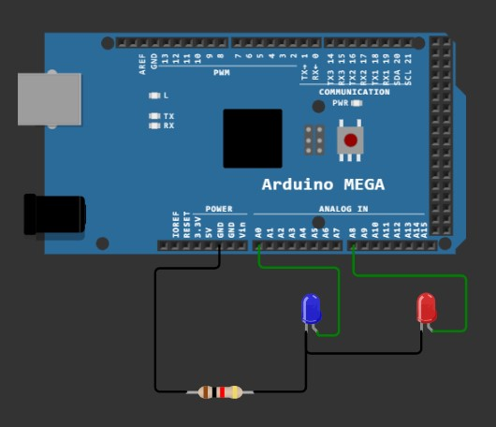
03. Timer0 programming in Normal Mode:-  ( Another program of Normal Mode using Interrupt are at the last of the 8-bit Timer/Counter )  uint8_t i=0;  void setup() {  Serial.begin(9600);  DDRB = 1;  TCCR0B = 5; // 5 for 1024 prescaler  TCNT0 = 0;  while(1){  if(TCNT0>=255){  i++;  if(i%20==0){  PORTB ^= 1;  Serial.println(i);  }  TCNT0=0;  }  }  }  void loop() {} | 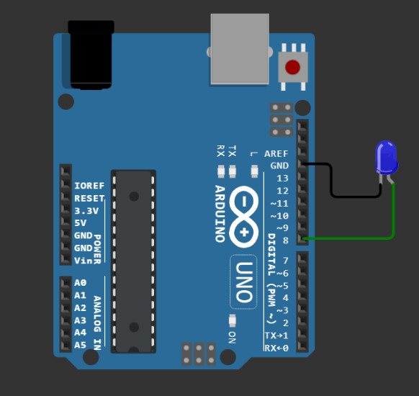  From 03, all program written by myself
04. Timer0 programming in CTC Mode, OC0A pin toggling on compare match:-  uint8_t count_compare;  void setup() {  Serial.begin(9600);  DDRD |= 64; // Set pin6 as Output  TCCR0A = 64+2; // 64 for toggling OC0A pin on compare match & 2 for CTC mode  TCCR0B = 5; // 5 for 1024 prescaler  TCNT0 = 0;  OCR0A = 255;  while(1){  if(TCNT0==250){  count_compare++;  Serial.println(count_compare);  }  }  }  void loop() {}  // Output > Toggled the OC0A pin (i.e., Arduino pin 6) | 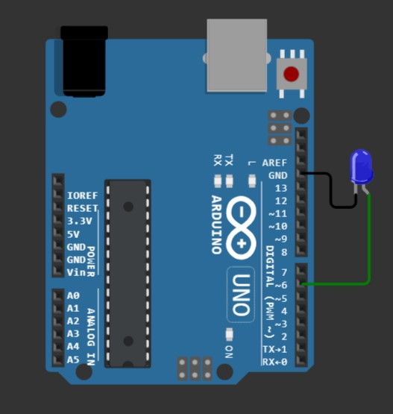  For OC0A Pin Operation
05. Timer0 programming in CTC Mode, OC0B pin toggling on compare match:-  uint8_t count_compare;  void setup() {  Serial.begin(9600);  DDRD |= 32; // Set pin5 as Output  TCCR0A = 2 + 16; // 16 for toggling OC0B pin on compare match & 2 for CTC mode  TCCR0B = 5; // 5 for 1024 prescaler  TCNT0 = 0;  OCR0A = 255;  while(1){  if(TCNT0==250){  count_compare++;  Serial.println(count_compare);  }  }  }  void loop() {}  // Output > Toggled the OC0B pin (i.e., Arduino pin 5) | 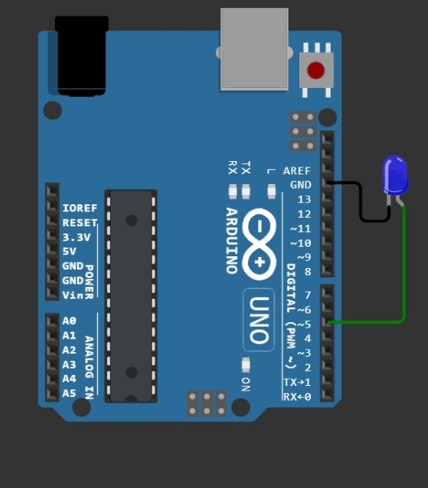  For OC0B Pin Operation
06. Timer0 programming in Fast PWM (Inverting) Mode for OC0A pin:-  void setup() {  DDRD |= 64; // Set pin6 as Output  TCCR0A = 128+64+2+1; // 128+64 for inverting mode PWM & 2+1 for Fast PWM generation  // Inverting mode means set OC0A on compare match and clear OC0A at bottom  TCCR0B = 5; // 5 for 1024 prescaler  TCNT0 = 0;  OCR0A = 255; // According to the value of OCR0A, output will change  while(1){}  }  void loop() {}  // Output > PWM output at OC0A pin (i.e., Arduino pin 6) | 07. Timer0 programming in Fast PWM (Non - Inverting) Mode for OC0A pin:-  void setup() {  DDRD |= 64; // Set pin6 as Output  TCCR0A = 128+2+1; // 128 for non-inverting mode PWM & 2+1 for Fast PWM generation  // Non-inverting mode means clear OC0A on compare match and set OC0A at bottom  TCCR0B = 5; // 5 for 1024 prescaler  TCNT0 = 0;  OCR0A = 25; // According to the value of OCR0A, output will change  while(1){}  }  void loop() {}  // Output > PWM output at OC0A pin (i.e., Arduino pin 6)
08. Timer0 programming in Fast PWM (Inverting) Mode for OC0B pin:-  void setup() {  DDRD |= 32; // Set pin5 as Output  TCCR0A = 32+16+2+1; // 32+16 for inverting mode PWM & 2+1 for Fast PWM generation  // Inverting mode means set OC0B on compare match and clear OC0B at bottom  TCCR0B = 5; // 5 for 1024 prescaler  TCNT0 = 0;  OCR0B = 255; // According to the value of OCR0B, output will change  while(1){}  }  void loop() {}  // Output > PWM output at OC0B pin (i.e., Arduino pin 5) | 09. Timer0 programming in Fast PWM (Non - Inverting) Mode for OC0B pin:-  void setup() {  DDRD |= 32; // Set pin5 as Output  TCCR0A = 32+2+1; // 32 for non-inverting mode PWM & 2+1 for Fast PWM generation  // Non-inverting mode means clear OC0B on compare match and set OC0B at bottom  TCCR0B = 5; // 5 for 1024 prescaler  TCNT0 = 0;  OCR0B = 25; // According to the value of OCR0B, output will change  while(1){}  }  void loop() {}  // Output > PWM output at OC0B pin (i.e., Arduino pin 5)
10. Timer0 programming in Phase Correct PWM Mode (COM0A1=1 & COM0A0=1) for OC0A pin:-  void setup() {  DDRD |= 64; // Set pin6 as Output  TCCR0A = 128+64+1; // 128+64 for set OC0A on compare match when up-counting  // and clear OC0A on compare match when down-counting & 1 for Phase Correct PWM generation  TCCR0B = 5; // 5 for 1024 prescaler  TCNT0 = 0;  OCR0A = 250; // According to the value of OCR0A, output will change  while(1){}  }  void loop() {}  // Output > PWM output at OC0A pin (i.e., Arduino pin 6) | 11. Timer0 programming in Phase Correct PWM Mode (COM0A1=1 & COM0A0=0) for OC0A pin:-  void setup() {  DDRD |= 64; // Set pin6 as Output  TCCR0A = 128+1; // 128 for clear OC0A on compare match when up-counting  // and set OC0A on compare match when down-counting & 1 for Phase Correct PWM generation  TCCR0B = 5; // 5 for 1024 prescaler  TCNT0 = 0;  OCR0A = 10; // According to the value of OCR0A, output will change  while(1){}  }  void loop() {}  // Output > PWM output at OC0A pin (i.e., Arduino pin 6)
12. Timer0 programming in Phase Correct PWM Mode (COM0B1=1 & COM0B0=1) for OC0B pin:-  void setup() {  DDRD |= 32; // Set pin5 as Output  TCCR0A = 32+16+1; // 32+16 for set OC0B on compare match when up-counting  // and clear OC0B on compare match when down-counting & 1 for Phase Correct PWM generation  TCCR0B = 5; // 5 for 1024 prescaler  TCNT0 = 0;  OCR0B = 250; // According to the value of OCR0B, output will change  while(1){}  }  void loop() {}  // Output > PWM output at OC0B pin (i.e., Arduino pin 5) | 13. Timer0 programming in Phase Correct PWM Mode (COM0B1=1 & COM0B0=0) for OC0B pin:-  void setup() {  DDRD |= 32; // Set pin5 as Output  TCCR0A = 32+1; // 32 for clear OC0B on compare match when up-counting  // and set OC0B on compare match when down-counting & 1 for Phase Correct PWM generation  TCCR0B = 5; // 5 for 1024 prescaler  TCNT0 = 0;  OCR0B = 10; // According to the value of OCR0B, output will change  while(1){}  }  void loop() {}  // Output > PWM output at OC0B pin (i.e., Arduino pin 5)
14. Timer2 programming, Normal Mode, using Overflow Interrupt. (Timer0 Overflow Interrupt not working) :-  void setup() {  Serial.begin(9600);  TCCR2A = 0; // Normal Mode  TCCR2B = 5; // 5 for 1024 prescaler  TIMSK2 = 1; // enable the Timer2 Overflow Interrupt  TCNT2 = 0;  while(1){}  }  ISR(TIMER2_OVF_vect){  Serial.println("hello world");  }  void loop() {} | 15. Timer0 programming, CTC Mode Compare Match A:-  void setup() {  Serial.begin(9600);  TCCR0A = 2; // CTC Mode  TCCR0B = 5; // 5 for 1024 prescaler  TIMSK0 = 2; // enable the Timer0 Output Compare Match A Interrupt  TCNT0 = 0;  OCR0A = 250;  while(1){}  }  ISR(TIMER0_COMPA_vect){  Serial.println("hello world");  }  void loop() {}
16. Timer0 programming, CTC Mode Compare Match B:-  void setup() {  Serial.begin(9600);  TCCR0A = 2; // CTC Mode  TCCR0B = 5; // 5 for 1024 prescaler  TIMSK0 = 4; //enable the Timer0 Output Compare Match B Interrupt  TCNT0 = 0;  OCR0A = 250; // if I use OCR0B = 250; then not working, may be it is the problem of the wokwi simulator  while(1){}  }  ISR(TIMER0_COMPB_vect){  Serial.println("hello world");  }  void loop() {} | 17. Use of TIFR Register (self) :-  volatile long i=0;  void setup() {  Serial.begin(9600);  TCCR0A = 2; // CTC Mode  TCCR0B = 5; // 5 for 1024 prescaler  TIMSK0 = 2; // enable the Timer0 Output Compare Match A Interrupt  TCNT0 = 0;  OCR0A = 250;  while(1){  if(i%100==0)  {Serial.println("hello world"); i++;}  }  }  ISR(TIMER0_COMPA_vect){  if((TIFR0 & 2)==0)  i++;  }  void loop() {}
18. Brightness Control by using PWM Mode (self-written-code) :-  volatile uint8_t count_flag, brightness=0;  void setup() {  DDRD |= 64; // Set pin6 as Output  TCCR0A = 128+64+2+1; // 128+64 for inverting mode PWM & 2+1 for Fast PWM generation  // Inverting mode means set OC0A on compare match and clear OC0A at bottom  TCCR0B = 5; // 5 for 1024 prescaler  TCNT0 = 0;  OCR0A = 255; // According to the value of OCR0A, output will change  TIMSK0 = 2; // Enable the Timer/Counter0 Output Compare Match A Interrupt  while(1){}  }  ISR(TIMER0_COMPA_vect){  if(brightness==0) count_flag=0;  if(brightness>250) count_flag=1;  if(count_flag==0) brightness+=3;  else brightness-=3;  OCR0A = brightness;  }  void loop() {} | 19. Counter Programming by using Timer/Counter0 :-  void setup() {  Serial.begin(9600);  DDRB = 1;  TCCR0A = 0; // Normal Mode  TCCR0B = 7; // 7 for selecting External Clock source on T0 pin (Rising Edge)  TCNT0 = 0;  while(1){  if(PORTB & 1) Serial.println(TCNT0);  PORTB ^= 1;  for(volatile long i=0; i<5000; i++);  if(TCNT0>250) TCNT0=0;  }  }  void loop() {}
01. Timer1 programming in Normal Mode:-  void setup() {  DDRB = 32; // PORTB 5th bit set as Output  TCCR1A = 0; // 0 for Normal Mode  TCCR1B = 5; // 5 for selecting 1024 prescaler  TCNT1 = 0;  while(1){  if(TCNT1>=10000){  PORTB ^= 32;  TCNT1=0;  }  }  }  void loop() {} | 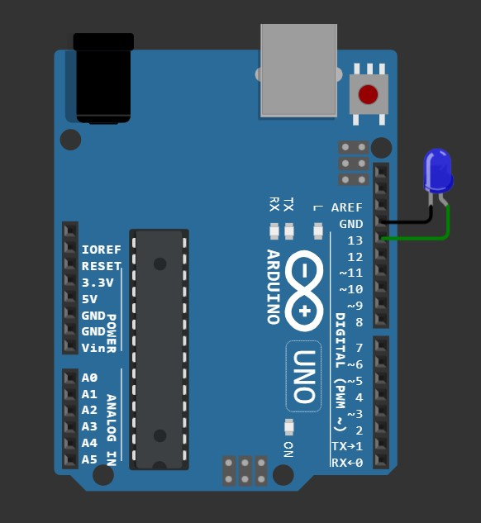
02. Timer1 programming, Normal Mode, using Overflow Interrupt :-  void setup() {  DDRB = 32; // PORTB 5th bit set as Output  TCCR1A = 0; // 0 for Normal Mode  TCCR1B = 3; // 3 for selecting 64 prescaler  TIMSK1 = 1; // for setting the Overflow Flag  TCNT1 = 0;  while(1){}  }  ISR(TIMER1_OVF_vect){  PORTB ^= 32;  }  void loop() {} | 
Timer1 (16-bit Timer/Counter) Programming

03. Timer1 programming in CTC Mode, OC1A pin toggling on compare match:-  void setup() {  DDRB = 2; // PORTB 1st bit set as Output  TCCR1A = 64; // 64 for toggling OC1A pin on compare match  TCCR1B = 5 + 8; // 5 for selecting 1024 prescaler & 8 for selecting CTC Mode  OCR1A = 5000;  TCNT1 = 0;  while(1){}  }  void loop() {} | 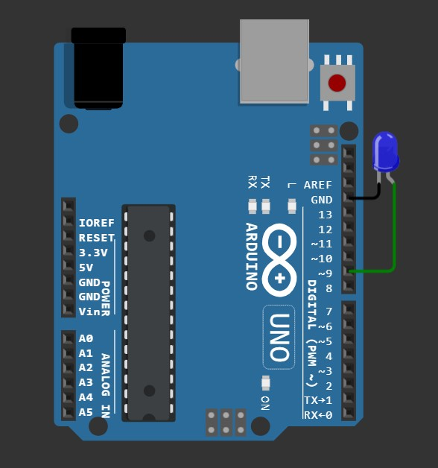  For OC1A Pin Operation
04. Timer1 programming in CTC Mode, OC1B pin toggling on compare match:-  void setup() {  DDRB = 4; // PORTB 2nd bit set as Output  TCCR1A = 16; // 16 for toggling OC1B pin on compare match  TCCR1B = 5 + 8; // 5 for selecting 1024 prescaler & 8 for selecting CTC Mode  OCR1A = 5000;  TCNT1 = 0;  while(1){}  }  void loop() {} | 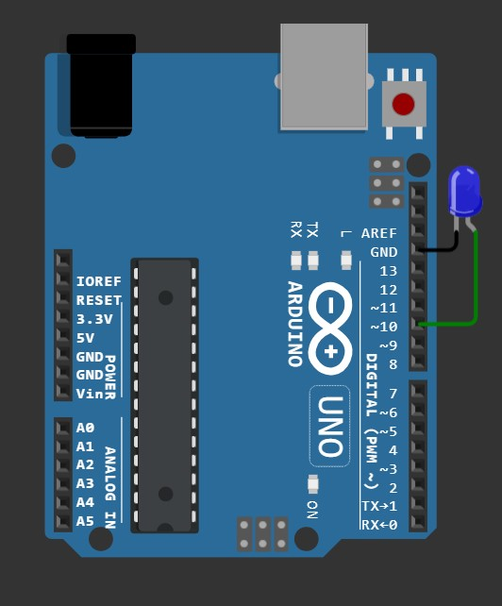  For OC1B Pin Operation

05. Timer1 programming in Fast PWM (10-bit & Inverting) Mode for OC1A pin:-  void setup() {  DDRB = 2; // PORTB 1st bit set as Output  TCCR1A = 128 + 64 + 2 + 1; // 128 + 64 for Set OC1A on compare match,  //clear OC1A at BOTTOM (inverting mode)  // and 2 + 1 for selecting Fast PWM, 10-bit  TCCR1B = 4 + 8; // 4 for selecting 256 prescaler & 8 for selecting Fast PWM, 10-bit  OCR1A = 1000;  TCNT1 = 0;  while(1){}  }  void loop() {} | 06. Timer1 programming in Fast PWM (10-bit Non - Inverting) Mode for OC1A pin:-  void setup() {  DDRB = 2; // PORTB 1st bit set as Output  TCCR1A = 128 + 2 + 1; // 128 for clear OC1A on compare match,  //set OC1A at BOTTOM (Non-inverting mode)  // and 2 + 1 for selecting Fast PWM, 10-bit  TCCR1B = 4 + 8; // 4 for selecting 256 prescaler & 8 for selecting Fast PWM, 10-bit  OCR1A = 10;  TCNT1 = 0;  while(1){}  }  void loop() {}
07. Timer1 programming in Fast PWM (10-bit Inverting) Mode for OC1B pin:-  void setup() {  DDRB = 4; // PORTB 2nd bit set as Output  TCCR1A = 32 + 16 + 2 + 1; // 32 + 16 for set OC1B on compare match, clear OC1B at BOTTOM (inverting mode)  // and 2 + 1 for selecting Fast PWM, 10-bit  TCCR1B = 4 + 8; // 4 for selecting 256 prescaler & 8 for selecting Fast PWM, 10-bit  OCR1B = 1000;  TCNT1 = 0;  while(1){}  }  void loop() {} | 08. Timer1 programming in Fast PWM (10-bit Non - Inverting) Mode for OC1B pin:-  void setup() {  DDRB = 4; // PORTB 2nd bit set as Output  TCCR1A = 32 + 2 + 1; // 32 for clear OC1B on compare match, set OC1B at BOTTOM (Non-inverting mode)  // and 2 + 1 for selecting Fast PWM, 10-bit  TCCR1B = 4 + 8; // 4 for selecting 256 prescaler & 8 for selecting Fast PWM, 10-bit  OCR1B = 10;  TCNT1 = 0;  while(1){}  }  void loop() {}

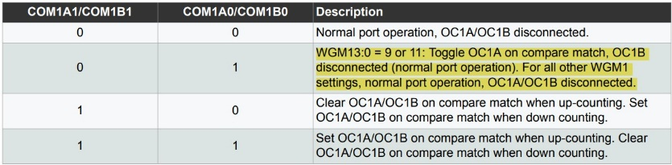
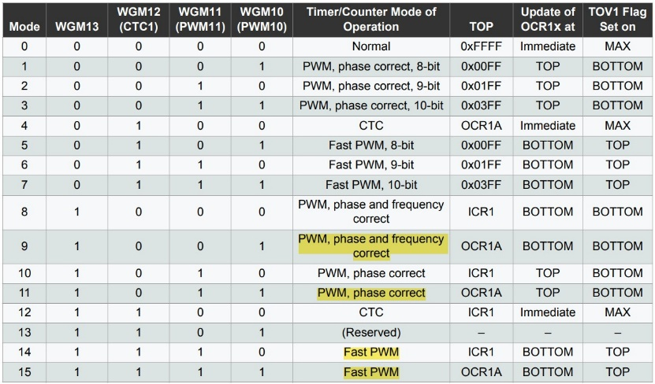  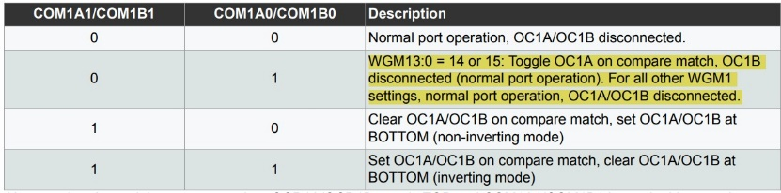  09. The High-lighted Modes are not done for the confusion :- | 10. Timer1 programming in Phase Correct PWM Mode [10-bit] (COM0A1=1 & COM0A0=1) for OC1A pin:-  void setup() {  DDRB = 2; // PORTB 1st bit set as Output  TCCR1A = 128 + 64 + 2 + 1; // 128 + 64 for set OC1A on compare match when up-counting  // & clear OC1A on compare match when down counting.  // and 2 + 1 for selecting PWM, phase correct, 10-bit  TCCR1B = 4 ; // 4 for selecting 256 prescaler  OCR1A = 1000;  TCNT1 = 0;  while(1){}  }  void loop() {}
11. Timer1 programming in Phase Correct PWM Mode [10-bit] (COM0A1=1 & COM0A0=0) for OC1A pin:-  void setup() {  DDRB = 2; // PORTB 1st bit set as Output  TCCR1A = 128 + 2 + 1; // 128 for clear OC1A on compare match when up-counting  // & set OC1A on compare match when down counting.  // and 2 + 1 for selecting PWM, phase correct, 10-bit  TCCR1B = 4 ; // 4 for selecting 256 prescaler  OCR1A = 10;  TCNT1 = 0;  while(1){}  }  void loop() {} | 12. Timer1 programming in Phase Correct PWM Mode [10-bit] (COM1B1=1 & COM1B0=1) for OC1B pin:-  void setup() {  DDRB = 4; // PORTB 2nd bit set as Output  TCCR1A = 32 + 16 + 2 + 1; // 32 + 16 for set OC1B on compare match when up-counting  // & clear OC1B on compare match when down counting.  // and 2 + 1 for selecting PWM, phase correct, 10-bit  TCCR1B = 4 ; // 4 for selecting 256 prescaler  OCR1B = 1000;  TCNT1 = 0;  while(1){}  }  void loop() {}

13. Timer1 programming in Phase Correct PWM Mode [10-bit] (COM1B1=1 & COM1B0=0) for OC1B pin:-  void setup() {  DDRB = 4; // PORTB 2nd bit set as Output  TCCR1A = 32 + 2 + 1; // 32 for clear OC1B on compare match when up-counting  // & set OC1B on compare match when down counting.  // and 2 + 1 for selecting PWM, phase correct, 10-bit  TCCR1B = 4 ; // 4 for selecting 256 prescaler  OCR1B = 10;  TCNT1 = 0;  while(1){}  }  void loop() {} | 14. Timer1 programming, CTC Mode Compare Match A:-  void setup() {  DDRB = 2; // PORTB 1st bit set as Output  TCCR1A = 0; // TCCR1A = 0 & TCCR1B = 8 for CTC Mode  TCCR1B = 8 + 4; // 4 for 256 prescaler  TIMSK1 = 2; // for selecting the Output Compare Match A Interrupt  OCR1A = 60000;  TCNT1 = 0;  while(1){}  }  ISR(TIMER1_COMPA_vect){  PORTB ^= 2;  }  void loop() {}
15. Timer1 programming, CTC Mode Compare Match B:-  void setup() {  DDRB = 2; // PORTB 1st bit set as Output  TCCR1A = 0; // TCCR1A = 0 & TCCR1B = 8 for CTC Mode  TCCR1B = 8 + 4; // 4 for 256 prescaler  TIMSK1 = 4; // for selecting the Output Compare Match B Interrupt  OCR1A = 60000;  TCNT1 = 0;  while(1){}  }  ISR(TIMER1_COMPB_vect){  PORTB ^= 2;  }  void loop() {} | 16. Use of TIFR Register (self) :-  void setup() {  DDRB = 2; // PORTB 1st bit set as Output  TCCR1A = 0; // TCCR1A = 0 & TCCR1B = 8 for CTC Mode  TCCR1B = 8 + 4; // 4 for 256 prescaler  TIMSK1 = 2; // for selecting the Output Compare Match A Interrupt  OCR1A = 60000;  TCNT1 = 0;  while(1){}  }  ISR(TIMER1_COMPA_vect){  if((TIFR1 & 2)==0)  PORTB ^= 2;  }  void loop() {}

